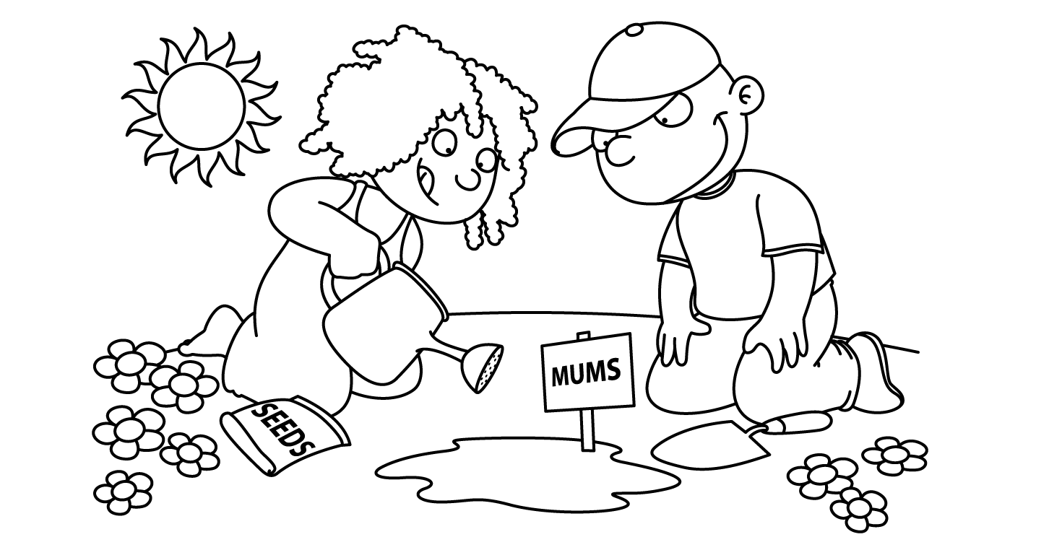

April Homework Calendar
Sunday | Monday | Tuesday | Wednesday | Thursday | Friday | Saturday
 | March  31 | 1 | 2 | 3 | 4 | 5
6 | 7  Spelling Tic-tac- toe board  Math Packet | 8 | 9 | 10 | 11 | 12
13 | 14  Spelling Tic-tac- toe board  Math Menu | 15 | 16 | 17 | 18 | 19
20 | 21  Spelling Tic-tac- toe board  Math Packet | 22 | 23 | 24 | 25 | 26
27 | 28  Catch-Up Week! | 29 | 30 | May  1 | May 2:  Turn in all homework and project of the month
**Please be sure to read at least 30 minutes a night!**

